COMPLIANCE GAP ANALYSIS
& MONITORING DASHBOARD
Technical Project Report
Prepared for the fictional ClearPath Financial Services Ltd.
Tools: Microsoft Excel • Power BI • Power Query • DAX
Report date: 23 October 2026

1. Executive Summary
This project demonstrates how a compliance team can use a structured dataset and an interactive Power BI report to monitor compliance requirements, identify gaps, and track corrective actions across departments. The report was built for a fictional financial services organisation, ClearPath Financial Services Ltd., using synthetic data created for portfolio demonstration purposes. It is not an assessment of a real organisation and does not provide legal or regulatory assurance.
The sample contains 20 compliance requirements and 8 corrective actions. At the time of analysis, 12 requirements are marked Compliant (60%), 5 are marked Gap Identified (25%), and 3 are In Progress (15%). The report presents an overview of compliance status and a second page for examining gaps and corrective-action activity.

2. Business Scenario and Problem Statement
In the scenario, ClearPath Financial Services tracks compliance-related requirements across IT, Operations, Finance, and HR. Information such as requirement status, priority, owner, review dates, supporting evidence, gap descriptions, and corrective actions needs to be visible to people responsible for monitoring and follow-up.
Without a consolidated view, managers may find it difficult to see how many requirements are compliant, where gaps are concentrated, which items need attention first, and what corrective actions remain open or under review.

Project objectives
- Create a single view of compliance requirements and corrective actions.
- Summarise compliance status using clear KPI cards and charts.
- Allow users to explore requirements by department, priority, and compliance status.
- Highlight identified gaps and provide a detailed gap register.
- Demonstrate data preparation, data modelling, DAX measures, and report design in Power BI.

3. Data Sources and Structure
The source workbook is ClearPath_Compliance_Dataset.xlsx. It contains two structured Excel tables and a Read Me sheet. The dataset is synthetic and should be described as sample or mock data whenever the project is presented.
Table / sheet | Rows | Purpose
Compliance Requirements (tblComplianceRequirements) | 20 requirements | Stores requirement details, department, control area, compliance status, priority, owners, evidence notes, gap descriptions, review dates, and corrective-action status.
Corrective Actions (tblCorrectiveActions) | 8 actions | Stores action ID, linked requirement ID, action description, department, priority, action owner, action status, target date, and notes.
Read Me | Reference sheet | Explains the workbook and its sample-data context.

Key fields
The Compliance Requirements table includes Requirement ID, Requirement, Department, Control Area, Compliance Status, Priority, Last Reviewed, Next Review Due, Owner, Evidence / Notes, Gap Description, and Corrective Action Status. The Corrective Actions table includes Action ID, Requirement ID, Corrective Action, Department, Priority, Action Owner, Action Status, Target Date, and Action Notes.

4. Data Preparation
The two Excel tables were imported into Power BI Desktop using Power Query. The queries were named Compliance Requirements and Corrective Actions to make the model and field list easier to understand. The tables were then loaded into the Power BI data model.
- Confirmed that the two source tables were available in Power Query and Power BI.
- Used Requirement ID to link corrective actions to their associated compliance requirements.
- Kept requirement-level compliance status separate from action-level status. Compliance Status describes the state of a requirement; Action Status describes the state of an action.
- Used the workbook's existing status labels: Compliant, Gap Identified, and In Progress for requirements; Open, In Progress, and Under Review for corrective actions.
The report was designed to remain connected to the Excel workbook through the named tables tblComplianceRequirements and tblCorrectiveActions. For the current desktop workflow, updated workbook data is reflected after refreshing the report in Power BI Desktop. If the workbook is moved or renamed, the source connection may need to be updated.

5. Data Model
The model connects Compliance Requirements[Requirement ID] to Corrective Actions[Requirement ID]. One requirement may be associated with one or more corrective actions, so the intended relationship is one-to-many from Compliance Requirements to Corrective Actions. This relationship allows users to analyse corrective-action records in the context of the related requirement.
A key modelling principle is to avoid treating the two status fields as interchangeable. Compliance Status is used for requirement-level analysis; Action Status is used for the corrective-action status chart.

6. DAX Measures
The following measures support the KPI cards and monitoring metrics in the report.

Total Requirements
Total Requirements = COUNTROWS('Compliance Requirements')
Counts all requirement records.

Compliant Requirements
Compliant Requirements = CALCULATE([Total Requirements], 'Compliance Requirements'[Compliance Status] = "Compliant")
Counts requirements marked Compliant.

Identified Gaps
Identified Gaps = CALCULATE([Total Requirements], 'Compliance Requirements'[Compliance Status] = "Gap Identified")
Counts requirements marked Gap Identified.

In Progress
In Progress = CALCULATE([Total Requirements], 'Compliance Requirements'[Compliance Status] = "In Progress")
Counts requirements marked In Progress.

Compliance Rate (%)
Compliance Rate (%) = DIVIDE([Compliant Requirements], [Total Requirements], 0)
Compliant requirements divided by total requirements. Format as Percentage with one decimal place.

Gap Rate (%)
Gap Rate (%) = DIVIDE([Identified Gaps], [Total Requirements], 0)
Identified gaps divided by total requirements. Format as Percentage with one decimal place.

Total Corrective Actions
Total Corrective Actions = COUNTROWS('Corrective Actions')
Counts all corrective-action records.

Overdue Reviews
Overdue Reviews = CALCULATE(COUNTROWS('Compliance Requirements'), FILTER('Compliance Requirements', 'Compliance Requirements'[Next Review Due] < TODAY() && NOT ISBLANK('Compliance Requirements'[Next Review Due])))
Counts requirements with a nonblank next-review date earlier than today's date. This value changes over time.
Expected base totals for the supplied sample data are 20 total requirements, 12 compliant requirements, 5 identified gaps, 3 requirements in progress, a 60.0% compliance rate, a 25.0% gap rate, and 8 corrective actions. Slicers can change these figures when they filter the report.

7. Dashboard Design and Functionality

Page 1: Compliance Overview
- KPI cards: Total Requirements, Compliant Requirements, Identified Gaps, In Progress, and Compliance Rate (%).
- Donut chart: Compliance Status Breakdown, showing the distribution of requirement statuses.
- Bar chart: Compliance Requirements by Department, comparing requirement counts across departments.
- Sidebar slicers: Department, Priority, and Compliance Status.
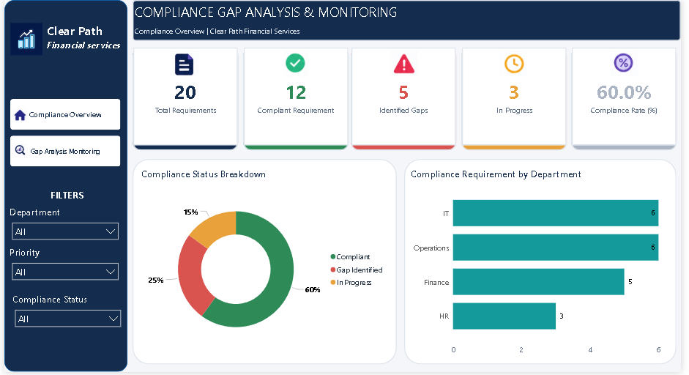

Page 2: Gap Analysis & Monitoring
- Gaps by Priority: compares identified gaps by priority.
- Gaps by Department: shows where identified gaps are concentrated.
- Corrective Actions by Status: summarises action records across Open, In Progress, and Under Review.
- Compliance Gap Register: provides row-level details including requirement ID, requirement, department, control area, priority, owner, gap description, corrective-action status, and next review due date.
- Sidebar slicers and visual interactions: configured so the Compliance Status slicer filters the two gap charts and the gap register, while not filtering the Corrective Actions by Status chart.
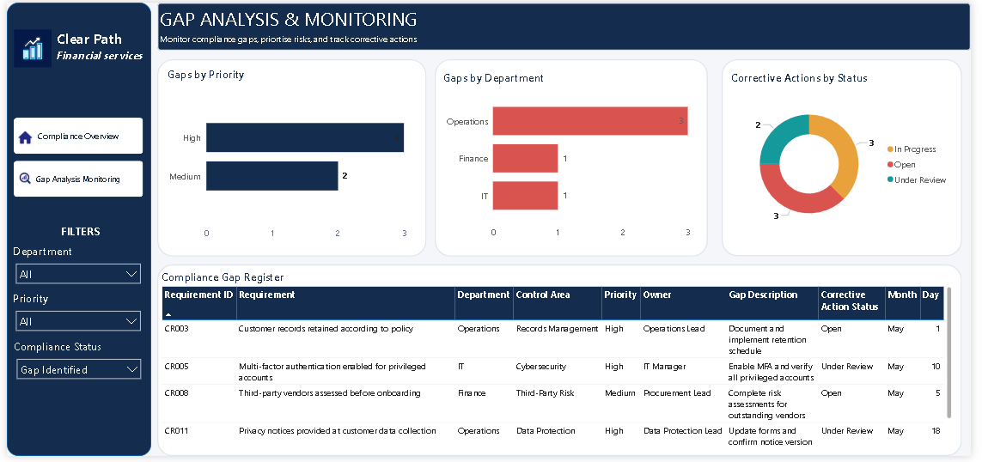
The dashboard uses a navy and purple visual theme, with status colours to help users distinguish compliant items, identified gaps, and work in progress. Visual-level filters establish default views for the gap visuals, while Edit interactions controls whether the sidebar Compliance Status slicer affects a visual.

8. Key Findings from the Sample Data
Metric | Sample result | Interpretation
Total requirements | 20 | The report tracks 20 requirement records.
Compliant | 12 (60.0%) | Three-fifths of the sample requirements are marked compliant.
Gap Identified | 5 (25.0%) | One quarter of the sample requirements are flagged as gaps.
In Progress (requirements) | 3 (15.0%) | Three requirements are still in progress.
Corrective actions | 8 | Eight action records are available for monitoring.
Action statuses | Open: 3; In Progress: 3; Under Review: 2 | Action status categories are distinct from requirement compliance statuses.

Gap distribution in the synthetic dataset:
- Operations: 3 identified gap(s).
- IT: 1 identified gap(s).
- Finance: 1 identified gap(s).
- High priority: 3 identified gap(s).
- Medium priority: 2 identified gap(s).
Operations has the highest number of identified gaps in this sample (3 of 5). Three of the five identified gaps are marked High priority, and the remaining two are Medium priority. No identified gap in this sample is marked Low priority. These observations describe only the synthetic dataset and should not be interpreted as real-world performance.

9. Recommendations for the Fictional Management Team
- Review the three identified gaps in Operations first, while confirming each item's risk and business impact before assigning final priority.
- Prioritise the three High-priority gaps for owner confirmation, evidence review, and a documented remediation plan.
- Assign clear action owners and target dates to all corrective actions, and regularly review items that remain Open or Under Review.
- Use the Next Review Due field and the Overdue Reviews measure to plan review activity; validate dates and refresh the report before each review meeting.
- Keep evidence notes and gap descriptions specific enough that another reviewer can understand the issue and the expected closure evidence.
- Refresh the Power BI report after updating the Excel tables, then verify that the visuals and totals reflect the latest data.

10. Testing and Quality Checks
- Verified expected totals against the source workbook: 20 requirements and 8 corrective actions.
- Checked the requirement status distribution: 12 Compliant, 5 Gap Identified, and 3 In Progress.
- Tested Department, Priority, and Compliance Status slicers.
- Configured Compliance Status slicer interactions so Corrective Actions by Status remains independent of requirement compliance status.
- Confirmed that the gap visuals and register can use visual-level filters for their default Gap Identified view.
- Recommended final test: clear all slicers and confirm the report returns to its expected default view before capturing portfolio screenshots.

11. Limitations and Next Steps
This is a portfolio demonstration using synthetic data. It has not been validated against actual regulations, internal policies, evidence files, or a real organisation's compliance obligations. The dataset is small and should not be used to draw statistical conclusions about any sector. The report supports monitoring and prioritization it does not replace legal advice, compliance-owner judgement, or a formal audit.
Future improvements could include a documented data dictionary, evidence links, a more formal risk-scoring method, action ageing, automated refresh where supported by the hosting environment, and role-based access controls for sensitive compliance information.

12. Conclusion
The project demonstrates an end-to-end reporting workflow: preparing structured Excel data, modelling linked tables, creating DAX measures, designing interactive report pages, and translating the results into practical monitoring recommendations. It provides a foundation for discussing Power BI, data analysis, process monitoring, and compliance reporting skills in a portfolio or interview.

